A person traveling on funds provided by the federal government must use a U.S. flag carrier (an airline owned by an American company), regardless of cost or convenience.

When scheduling international travel that is federally funded, you must ensure that all flights, where possible, are scheduled on **U.S. flag carriers or on foreign air carriers that code share** with a U.S. flag carrier. Code sharing: when two or more airlines “code” the same flight as if it was their own.

A U.S. airline may sell a seat on the plane of a foreign air carrier; this seat is considered the same as one on a plane operated by a U.S. flag carrier. Compliance with the ***Fly America Act*** is satisfied when the U.S. flag air carrier's designator code is present in the area next to the flight numbers on the airline ticket, boarding pass, or on the documentation for an electronic ticket (passenger receipt) – see example below, where Delta Airlines (DL) has a code share agreement with Air France (AF) to Paris, France.

COMPLIANT

NOT COMPLIANT

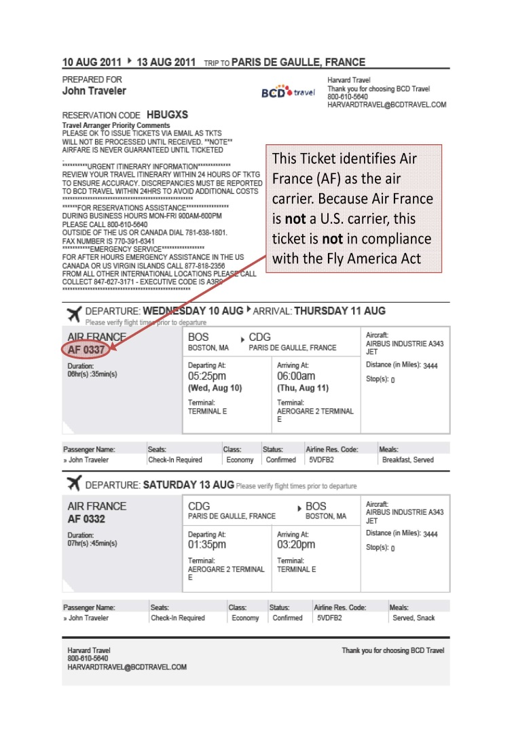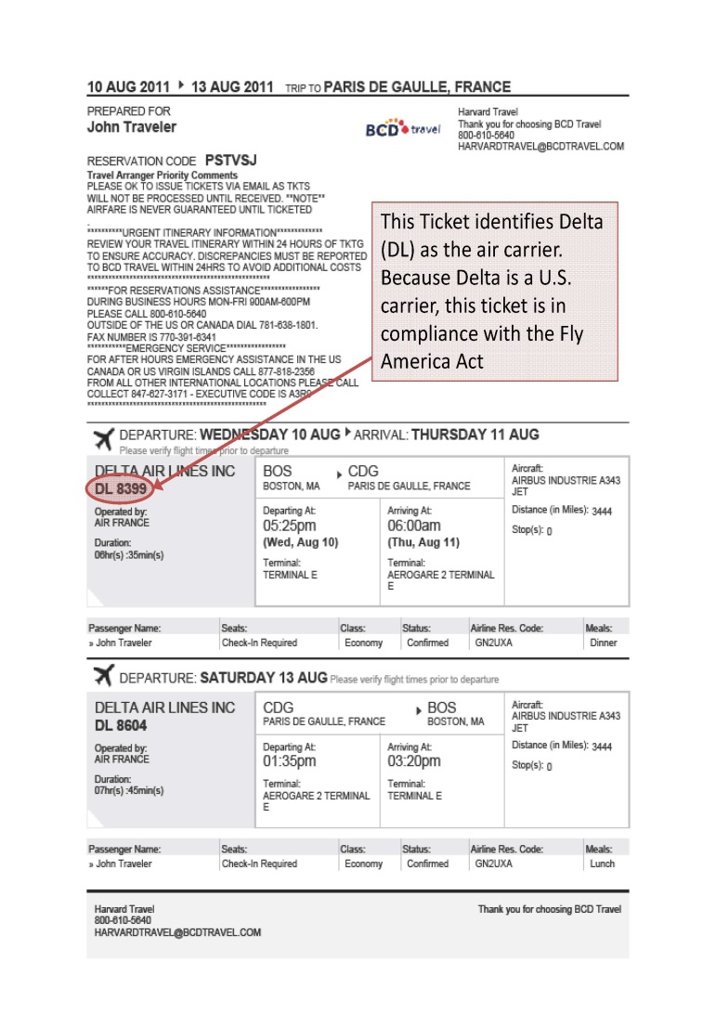

**US Flag Air Carriers -** U.S. flag carriers and their codes are below to assist you.

In order for a flight to be in compliance with the Fly America Act, the code of a U.S. flag air carrier must be noted as part of the flight number on the airline ticket, flight coupon (boarding pass*), or passenger receipt. Each airline has a two letter alpha code. From this list, you will be able to compare airline codes on the ticket with those on the list and thereby be able to ascertain whether or not the flight is on a US Flag air carrier.

U.S. flag air carriers:

• Airtran Airways (FL) • Alaska Airlines (AS) • American Airlines (AA)

• Continental Airlines (CO) • Delta Airlines (DL) • Frontier Airlines (F9)

• Hawaiian Airlines (HA) • JetBlue Airways (B6) • Midwest Express (YX)

• Southwest Airlines (WN) • Spirit Airlines (NK) • United Airlines (UA)

• USAirways (US)

It is highly recommended that you book your international travel, when federally funded, through University Preferred Travel Agencies. Our preferred agencies have agents that are well versed in the Fly America Act. *Please be sure to advise them that your trip is federally funded.* <http://www.dbs.umd.edu/travel/services/agents.php>

***Exceptions to the Fly America Act***

To document the exceptions, you must complete the Fly America Act Waiver Checklist. **Please see the Checklist on page 3.**

The biggest exception to the Fly America Act is the [Open Skies Agreement](http://www.gsa.gov/portal/content/103191). On October 6, 2010, the United States and European Union (EU) [Open Skies Air Transport Agreement](http://www.gsa.gov/graphics/ogp/FTRBulletin11-02USEUOpenSkies.PDF)  was published by the U.S. General Services Administration. This multilateral agreement is in place so that qualifying travelers, whose travel is supported by federal funds, may travel on EU airlines as well as U.S. Flag Air Carriers. There are also Open Skies agreement with Australia, Switzerland, and Japan. **Please see the Flow Chart on page 4.**

There are other exceptions to the Fly America Act which may be appropriate as well. A list of exception criteria may be found in the [Federal Travel Regulation Guidelines](http://www.gsa.gov/portal/ext/public/site/FTR/file/Chapter301p010.html/category/21868/#wp1088924)  – FTR sections 301-10.135-138. Please note that lower cost and personal convenience are not acceptable criteria for justifying the non- availability of a U.S. –flag air carrier.

**Please note:** Travelers using Department of Defense (DOD), Air Force, Army or Navy are not permitted to take advantage of Open Skies Agreements. These travelers must use an American carrier, unless they qualify for an exemption as noted in FTR 301-10.135, sections (a), (d), (e), (f), and (g).

**FLY AMERICA ACT WAIVER CHECKLIST**

***Please provide documentation for all checked items***

*(To assist in determining qualification for a waiver of the restrictions of the Fly America Act*

*under 41 CFR Part 301-10, check the applicable statement(s) below.)*

Use of foreign air carrier is a matter of necessity because of. *(****Must check one below****)*

U.S. flag air carrier cannot provide the air transportation needed, for example:

Use of foreign air carrier is necessary for medical reasons.

Use of foreign air carrier is required to avoid unreasonable risk to traveler’s safety. *(See 41*

*CFR 301-10.138(b)(2) for supporting evidence needed.)*

Seat on U.S. air carrier in authorized class of service is unavailable; seat on foreign air carrier

in authorized class of service is available.

Other (Provide detailed justification.)

Code sharing agreement exists. This two letter alpha code of a U.S. flag air carrier is clearly noted as part of

the flight number on the airline ticket, flight coupon (boarding pass), or passenger receipt.

Bilateral or multilateral air transportation agreement. U.S. is a party and Dept. of Transportation determines

agreement meets requirements of Fly America Act.

No U.S. flag air carrier provides service on a particular leg of your route *(Travelers can only use foreign air*

*carrier to or from the nearest interchange point to connect with a U.S. carrier).*

A U.S. flag air carrier involuntarily reroutes traveler on a foreign air carrier.

Service on a foreign air carrier is three hours or less, and use of U.S. flag air carrier doubles en route travel

time.

Air travel is between the U.S. and another country and use of a U.S. carrier on a nonstop flight extends

travel time by 24 hours or more.

Any other air travel (*You must check at least one of the following statements to qualify for a waiver of*

*the Fly America Act restrictions in this section)*

Use of a U.S. carrier increases the number of aircraft changes outside the U.S. by two or more.

Use of a U.S. carrier extends travel time by six hours or more.

Use of a U.S. carrier requires a connecting time of four hours or more at an overseas interchange point.

Remember, you **must use a U.S. flag air carrier on every portion of the route where it provides service** unless you qualify for a waiver. If a travel expense is disallowed, the department accepts liability of charges with departmental funds or identifies a suitable non-federal funding source to cover the disallowance.

_________________________________ ________________________________

**Name and Dept. of Traveler Dept. Chair/ Unit Head Signature**

_________________________________ ________________________________

**Signature of Traveler Date**



[European Countries](http://europa.eu/about-eu/countries/index_en.htm)

GSA's [City Pair Program](http://www.gsa.gov/portal/category/27228)

Please see the examples on the following pages. Examples provided compliments of [GlobeTrotter](http://globetrottermgmt.com/umd/).

**Travel to a European Union Country, Norway and Iceland**

According to the Open Skies agreement between the U.S. and [European Union (EU) countries](http://europa.eu/about-eu/countries/member-countries/index_en.htm), Norway or Iceland, you may fly on any EU airline but ONLY when:

**checkoffTravel is NOT funded by U.S. DOD** (Department of Defense) **or U.S. Military, AND**

**checkoffFlight touches down in an EU country, Norway or Iceland**

For example, you are flying from...

* Frankfurt (E.U.) **–>** San Francisco (U.S.)
* San Francisco (U.S.) **–>** Paris (EU)
* Dublin (EU) **–>** NYC (U.S.) **–>** Vancouver (Non-U.S./Non-EU country)
* Mexico City (Non-U.S./Non-EU country) **–>** NYC (U.S.) **–>** Madrid (EU)
* Cleveland (U.S.) **–>** Montreal (Non-U.S./Non-EU country) **–>** Barcelona (EU)
* Vienna (EU) **–>** Toronto (Non-U.S./Non-EU country) **–>** Denver (U.S.)
* Istanbul (Non-U.S./Non-EU country) **–>** Amsterdam (EU) **–>** Memphis (U.S.)
* Orlando (U.S.) **–>** London (EU) **–>** Moscow (Non-U.S./Non-EU country)
* Washington DC (U.S.) **–>** Sarajevo (ECAA - European Common Aviation Area)
* Belgrade (ECAA - European Common Aviation Area) **–>** Washington DC (U.S.)

When both conditions are met, your may travel on any of the following airlines:

* [U.S. flag airlines](http://www.stanford.edu/group/fms/fingate/staff/travel/res_jobaid/us_flag_air_code_alliance.html)
* Austrian (Austria)
* Brussels Airlines (Belgium)
* Cyprus Airways (Cyprus)
* Czech Airlines (Czech Republic)
* Finnair (Finland)
* Air France (France)
* Air Berlin (Germany)
* Lufthansa (Germany)
* British Airways (Great Britain)
* British Midland International (Great Britain)
* Virgin Atlantic (Great Britain)
* Aegean Airlines (Greece)
* Olympic Air (Greece)
* Malev Hungarian Airlines (Hungary)
* Icelandair (Iceland)
* Alitalia (Italy)
* airBaltic (Latvia)
* Luxair (Luxembourg)
* Air Malta (Malta)
* KLM (The Netherlands)
* LOT Polish Airlines (Poland)
* TAP Portugal (Portugal)
* TAROM (Romania)
* Adria Airways (Slovinia)
* Iberia (Spain)
* SAS (Sweden)

This is not a complete list, but covers most common EU airlines.

**Travel to Australia**

According to the Open Skies agreement between the U.S. and Australia, you may fly on any Australian airline but ONLY when:

**checkoffTravel is NOT funded by U.S. DOD** (Department of Defense) **or U.S. Military, AND**

**checkoffU.S. government DOES NOT have a published airfare rate for your travel route (City-Pair Agreement)**

The GSA's [City Pair Program](http://www.gsa.gov/portal/category/27228) offers government negotiated fares for flights between certain cities. If a city-pair agreement is in effect, you may not claim an Open Skies exception and must fly on a US flag carrier or US code share carrier.

Check [Airfares City-Pair Search](http://apps.fas.gsa.gov/citypairs/search/) before booking flights to determine if a city-pair agreement is in effect. After entering your departure and arrival cities, the search tool will either display the city pair agreement fares, or will report "There are no awards for the requested city-pair," in which case the Open Skies Exemption can be used.

When both conditions are met, your may travel on any of the following airlines:

* [U.S. flag airlines](http://www.stanford.edu/group/fms/fingate/staff/travel/res_jobaid/us_flag_air_code_alliance.html)
* Qantas Airways
* Virgin Australia

**Travel to Japan**

According to the Open Skies agreement between the U.S. and Japan, you may fly on any Japanese airline but ONLY when:

**checkoffTravel is NOT funded by U.S. DOD** (Department of Defense) **or U.S. Military, AND**

**checkoffU.S. government DOES NOT have a published airfare rate for your travel route (City-Pair Agreement)**

The GSA's [City Pair Program](http://www.gsa.gov/portal/category/27228) offers government negotiated fares for flights between certain cities. If a city-pair agreement is in effect, you may not claim an Open Skies exception and must fly on a US flag carrier or US code share carrier.

Check [Airfares City-Pair Search](http://apps.fas.gsa.gov/citypairs/search/) before booking flights to determine if a city-pair agreement is in effect. After entering your departure and arrival cities, the search tool will either display the city pair agreement fares, or will report "There are no awards for the requested city-pair," in which case the Open Skies Exemption can be used.

When both conditions are met, your may travel on any of the following airlines:

* [U.S. flag airlines](http://www.stanford.edu/group/fms/fingate/staff/travel/res_jobaid/us_flag_air_code_alliance.html)
* Japan Airlines
* All Nippon Airways

**Travel to Switzerland**

According to the Open Skies agreement between the U.S. and Switzerland, you may fly on any Swiss airline but ONLY when:

**checkoffTravel is NOT funded by U.S. DOD** (Department of Defense) **or U.S. Military, AND**

**checkoffU.S. government DOES NOT have a published airfare rate for your travel route (City-Pair Agreement)**

The GSA's [City Pair Program](http://www.gsa.gov/portal/category/27228) offers government negotiated fares for flights between certain cities. If a city-pair agreement is in effect, you may not claim an Open Skies exception and must fly on a US flag carrier or US code share carrier.

Check [Airfares City-Pair Search](http://apps.fas.gsa.gov/citypairs/search/) before booking flights to determine if a city-pair agreement is in effect. After entering your departure and arrival cities, the search tool will either display the city pair agreement fares, or will report "There are no awards for the requested city-pair," in which case the Open Skies Exemption can be used.

When both conditions are met, your may travel on any of the following airlines:

* [U.S. flag airlines](http://www.stanford.edu/group/fms/fingate/staff/travel/res_jobaid/us_flag_air_code_alliance.html)
* Swiss International

**Travel to Other Countries**

checkoffWhen travel is supported by federal funds, you must fly on a U.S. flag airline unless you qualify for an exemption as noted in the Fly America Act. See [Additional Exceptions](http://www.stanford.edu/group/fms/fingate/staff/travel/policy_notes/fly_america_act.html#exception_additional) section below.

**Additional Exceptions**

Other strictly limited circumstances in which an exception may be allowed include:

* a U.S. flag carrier does not provide service on a particular leg of your trip,
* the use of a U.S. carrier will unreasonably delay your travel time
* you are involuntarily rerouted, or
* medical or safety reasons.

**Travel to Japan**

According to the Open Skies agreement between the U.S. and Japan, you may fly on any Japanese airline but ONLY when:

**checkoffTravel is NOT funded by U.S. DOD** (Department of Defense) **or U.S. Military, AND**

**checkoffU.S. government DOES NOT have a published airfare rate for your travel route (City-Pair Agreement)**

The GSA's [City Pair Program](http://www.gsa.gov/portal/category/27228) offers government negotiated fares for flights between certain cities. If a city-pair agreement is in effect, you may not claim an Open Skies exception and must fly on a US flag carrier or US code share carrier.

Check [Airfares City-Pair Search](http://apps.fas.gsa.gov/citypairs/search/) before booking flights to determine if a city-pair agreement is in effect. After entering your departure and arrival cities, the search tool will either display the city pair agreement fares, or will report "There are no awards for the requested city-pair," in which case the Open Skies Exemption can be used.

When both conditions are met, your may travel on any of the following airlines:

* [U.S. flag airlines](http://www.stanford.edu/group/fms/fingate/staff/travel/res_jobaid/us_flag_air_code_alliance.html)
* Japan Airlines
* All Nippon Airways

**Travel to Switzerland**

According to the Open Skies agreement between the U.S. and Switzerland, you may fly on any Swiss airline but ONLY when:

**checkoffTravel is NOT funded by U.S. DOD** (Department of Defense) **or U.S. Military, AND**

**checkoffU.S. government DOES NOT have a published airfare rate for your travel route (City-Pair Agreement)**

The GSA's [City Pair Program](http://www.gsa.gov/portal/category/27228) offers government negotiated fares for flights between certain cities. If a city-pair agreement is in effect, you may not claim an Open Skies exception and must fly on a US flag carrier or US code share carrier.

Check [Airfares City-Pair Search](http://apps.fas.gsa.gov/citypairs/search/) before booking flights to determine if a city-pair agreement is in effect. After entering your departure and arrival cities, the search tool will either display the city pair agreement fares, or will report "There are no awards for the requested city-pair," in which case the Open Skies Exemption can be used.

When both conditions are met, your may travel on any of the following airlines:

* [U.S. flag airlines](http://www.stanford.edu/group/fms/fingate/staff/travel/res_jobaid/us_flag_air_code_alliance.html)
* Swiss International

**Travel to Other Countries**

checkoffWhen travel is supported by federal funds, you must fly on a U.S. flag airline unless you qualify for an exemption as noted in the Fly America Act. See [Additional Exceptions](http://www.stanford.edu/group/fms/fingate/staff/travel/policy_notes/fly_america_act.html#exception_additional) section below.

**Additional Exceptions**

Other strictly limited circumstances in which an exception may be allowed include:

* a U.S. flag carrier does not provide service on a particular leg of your trip,
* the use of a U.S. carrier will unreasonably delay your travel time
* you are involuntarily rerouted, or
* medical or safety reasons.

**Travel to Other Countries**

checkoffWhen travel is supported by federal funds, you must fly on a U.S. flag airline unless you qualify for an exemption as noted in the Fly America Act. See [Additional Exceptions](http://www.stanford.edu/group/fms/fingate/staff/travel/policy_notes/fly_america_act.html#exception_additional) section below.

**Additional Exceptions**

Other strictly limited circumstances in which an exception may be allowed include:

* a U.S. flag carrier does not provide service on a particular leg of your trip,
* the use of a U.S. carrier will unreasonably delay your travel time
* you are involuntarily rerouted, or
* medical or safety reasons.

**Important Links**

**Fly American Links**

NIH <http://grants.nih.gov/grants/policy/nihgps_2011/nihgps_ch4.htm>

NSF <http://www.nsf.gov/pubs/policydocs/gc1/feb12.pdf>

<http://finance.tufts.edu/spa/files/Fly-America-Open-Skies-and-City-Pair-Matrix.pdf>

<http://finance.tufts.edu/spa/travel-on-sponsored-projects/>